**Transformer in**

**Natural Language Processing**

Student: De wei, Chyr(遲德威)

Student ID: M11202149

# Outline

Outline 1

Abstract 3

1. Introduction 3

2. Background 4

2.1 Neural Networks and Deep Learning 4

2.2 Sequence-to-Sequence Models 7

2.2.1 Encoder-Decoder Architecture 7

2.2.2 Attention Mechanism 7

2.2.3 Applications of Seq2Seq Models 8

3. The Transformer Model 9

3.1 Architecture Overview 9

3.1.1 Encoder 9

3.1.2 Decoder 10

3.1.3 Positional Encoding 11

3.2 Self-Attention Mechanism 12

3.2.1 Calculation of Self-Attention 12

3.2.2 Advantages of Self-Attention 13

3.2.3 Multi-Head Self-Attention 13

4. Applications of Transformers in NLP 14

4.1 Machine Translation 14

4.1.1 Traditional Approaches 14

4.1.2 Transformer Model in Machine Translation 15

4.1.3 Impact and Advancements 15

4.1.4 Example Translation 16

4.1.5 Challenges and Future Directions 16

4.2 Text Summarization 16

4.2.2 Transformer Model in Text Summarization 17

4.2.3 Impact and Advancements 17

4.2.4 Example Summarization 18

4.2.5 Challenges and Future Directions 18

4.3 Question Answering 19

4.3.1 Traditional Approaches 19

4.3.2 Transformer Model in Question Answering 19

4.3.3 Impact and Advancements 20

4.3.4 Example QA System 20

4.3.5 Challenges and Future Directions 20

4.4 Text Generation 21

4.4.1 Traditional Approaches 21

4.4.2 Transformer Model in Text Generation 21

4.4.3 Impact and Advancements 22

4.4.4 Example Text Generation 22

4.4.5 Challenges and Future Directions 22

5. Advantages and Limitations 23

5.1 Advantages 23

5.2 Limitations 24

6. Recent Developments and Future Directions 24

6.1 BERT and its Variants 24

6.2 GPT Series 25

6.3 Future Trends in Transformer Models 25

7. Conclusion 26

8. Reference 27

# Abstract

The Transformer model, as introduced by Vaswani et al. in 2017, has transformed the field of Natural Language Processing (NLP). By using a novel self-attention mechanism, the Transformer addresses limitations of traditional sequence-to-sequence models, such as Recurrent Neural Networks (RNNs) and Long Short-Term Memory (LSTM) networks. It enables more efficient parallel processing and captures long-range dependencies within text.

This report provides a comprehensive overview of the Transformer's architecture, including its encoder-decoder structure, self-attention mechanism, and positional encoding.

We also explore various applications of the Transformer in NLP, like machine translation, text summarization, question answering, and text generation, highlighting its advantages and limitations.

Furthermore, we examines recent developments, including models like BERT and GPT, and discuss future trends and potential directions for research in this area. Through this analysis, we aim to underscore the Transformer's significant impact on NLP and its ongoing evolution in the field.

# 1. Introduction

Natural Language Processing (NLP) is a vital area of artificial intelligence that focus on the interaction between computers and human language. It enable machines to understand, interpret, and generate human language in a valuable way.

Over the past few decades, NLP has seen tremendous advancements, particularly with the rise of machine learning and deep learning techniques. Traditional sequence-to-sequence models, like Recurrent Neural Networks (RNNs) and Long Short-Term Memory (LSTM) networks, have been widely used in NLP tasks. However, these models faces several limitations, including difficulty in handling long-range dependencies and inefficiencies in parallel processing.

To address these challenges, Vaswani et al. introduced the Transformer model in 2017, which employs a novel self-attention mechanism. This mechanism allows the model to weigh the importance of different words in a sequence, regardless of their position, thus overcoming the limitations of previous models.

The Transformer has become the foundation for numerous state-of-the-art NLP models as well as applications. The primary objective of this report is to provides a comprehensive overview of the Transformer model, including its architecture, working principles, and various applications in NLP. We will explore how the Transformer has been utilized in tasks like machine translation, text summarization, question answering, and text generation. Additionally, we will discuss the advantages and limitations of the Transformer, examine recent developments like BERT and GPT, and consider future trends and research directions in this rapidly evolving field.

This report is structured as follows: Section 2 provide background information on neural networks and sequence-to-sequence models. Section 3 delves into the architecture of the Transformer model. Section 4 discuss the applications of Transformers in various NLP tasks. Section 5 emphasize the advantages and limitations of the Transformer model. Section 6 reviews recent developments and future directions. Finally, Section 7 concludes the report with a summary of key points and potential future research areas.

# 2. Background

## 2.1 Neural Networks and Deep Learning

Neural networks and deep learning have revolutionize the field of artificial intelligence, enabling machines to perform complex tasks such as image recognition, speech synthesis, and natural language processing. At the core of these advancements is neural networks, which are computational models inspired by the human brain's structure and function. These networks consist of multiple layers of interconnected nodes, or neurons, that deal with the input data to gerneratte an output (Figure 1).

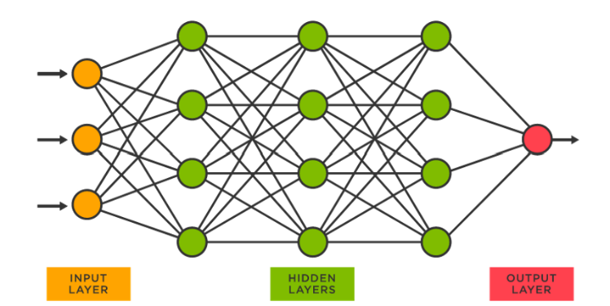

Fig. 1 Structure of a Neural Network

A general neural network includes an input layer, several hidden layers, and an output layer. Each neuron in a layer connects to neurons on the next layer through weighted connections. The learning process involves adjusting these weights based on the error between the predicted output and the actual output, typically using an optimization algorithm like gradient descent. This process is known as training the network.

Deep learning extends neural networks by increasing the number of hidden layers, leading to deep neural networks (DNNs). This depth allows the network to learn hierarchical representations of data, capturing intricate patterns and features. The advent of powerful computational resources and large datasets has enabled the training of deep networks, which have achieved remarkable success in various domains .

In the context of natural language processing (NLP), deep learning has facilitated significant progress. Traditional NLP methods relied heavily on handcrafted features and linguistic rules. However, deep learning models, such as Recurrent Neural Networks (RNNs) and Long Short-Term Memory (LSTM) networks, have demonstrated superior performance by automatically learning features from raw text data.

RNNs are specifically designed for sequential data, which makes them well-suited for tasks involving time series or sequences, like language modeling and machine translation. An RNN processes an input sequence one element at a time, maintaining a hidden state that captures information from previous elements. However, RNNs struggle with long-range dependencies due to the vanishing gradient problem, where gradients used for training diminish over time, preventing the network from learning effectively (Figure 2).

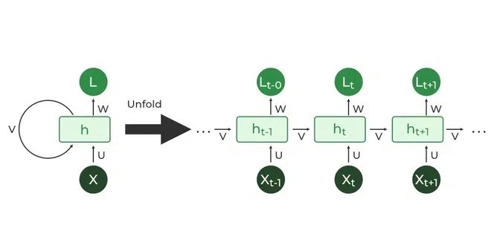

Fig. 2 Recurrent Neural Network (RNN) Structure

LSTM networks address this limitation by incorporating a memory cell and gating mechanisms that regulate the flow of information. These enhancements enable LSTMs to capture long-range dependencies more effectively than standard RNNs. Despite these improvements, LSTMs still face challenges related to parallel processing and scalability (Figure 3).

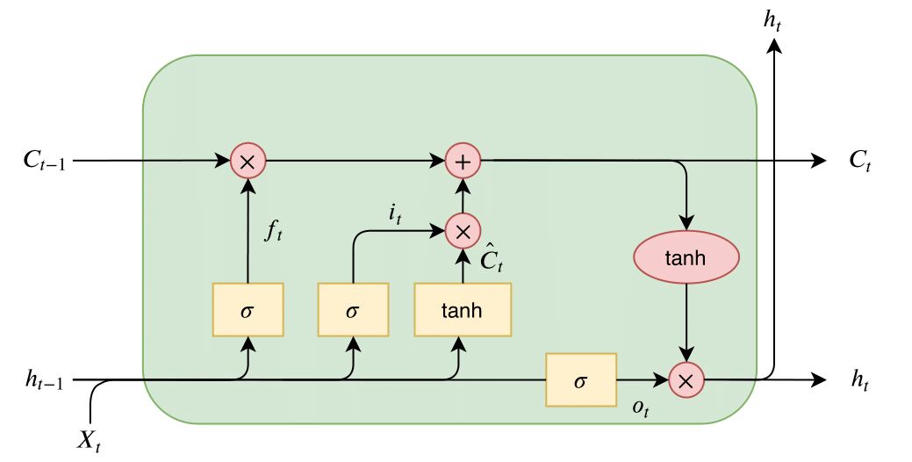

Fig. 3 Long Short-Term Memory (LSTM) Network Structure

The Transformer model, introduced by Vaswani et al. in 2017, emerged as a solution to these challenges. Unlike RNNs and LSTMs, the Transformer does not rely on sequential processing. Instead, it utilizes a self-attention mechanism that permits the model to simultaneously weigh the importance of different elements in a sequence, resulting in more effective parallelization and enhanced performance across various NLP tasks. (Figure 4).

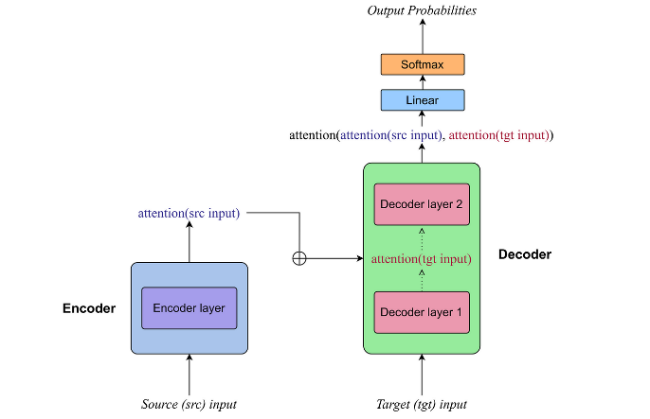

Fig. 4 Transformer Model Architecture

In summary, neural networks and deep learning have provided the foundation for modern NLP. While RNNs and LSTMs have contributed significantly to this progress, the introduction of the Transformer model has marked a new era in NLP, offering solutions to longstanding limitations and paving the way for future advancements.

## 2.2 Sequence-to-Sequence Models

Sequence-to-sequence (Seq2Seq) models have been a fundamental component in the advancement of natural language processing (NLP) tasks such as machine translation, text summarization, and dialogue systems. These models aim to convert sequences of one type (e.g., sentences in one language) to sequences of another type (e.g., sentences in another language), preserving the context and meaning throughout the transformation.

### 2.2.1 Encoder-Decoder Architecture

The core architecture of Seq2Seq models is the encoder-decoder framework (Figure 5). While the encoder processes the input sequence and compresses its information into a fixed-size context vector, this context vector, also known as the thought vector, compress the essence of the input sequence. The decoder then takes this context vector and generates the output sequence, one element at a time.

In a typical implementation, both the encoder and decoder are recurrent neural networks (RNNs). The encoder RNN reads the input sequence and updates its hidden state at each time step. The last hidden state of the encoder is utilized as the initial hidden state for the decoder RNN, which produces the output sequences.

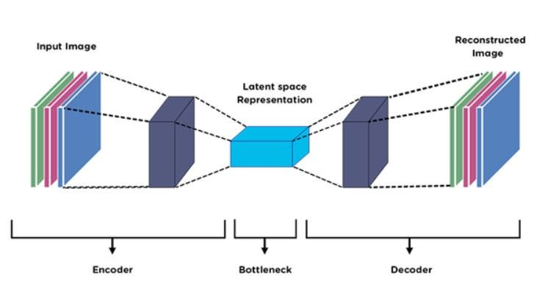

Fig. 5 Encoder-Decoder Architecture

### 2.2.2 Attention Mechanism

While the basic encoder-decoder architecture works well for short sequences, it struggles with long sequences due to the fixed-size context vector's limitations. This problem is fixed by the attention mechanism, which is introduced by Bahdanau et al. in 2014 . The attention mechanism allows the decoder to focus on different parts of the input sequence at each time step, effectively creating a dynamic context vector.

The attention mechanism computes a set of attention weights that indicate the importance of each input token for generating the current output token. These weights are utilized to make a weighted summ of the encoder's hiddem states, which serves as the context vector for the decoder at each time step.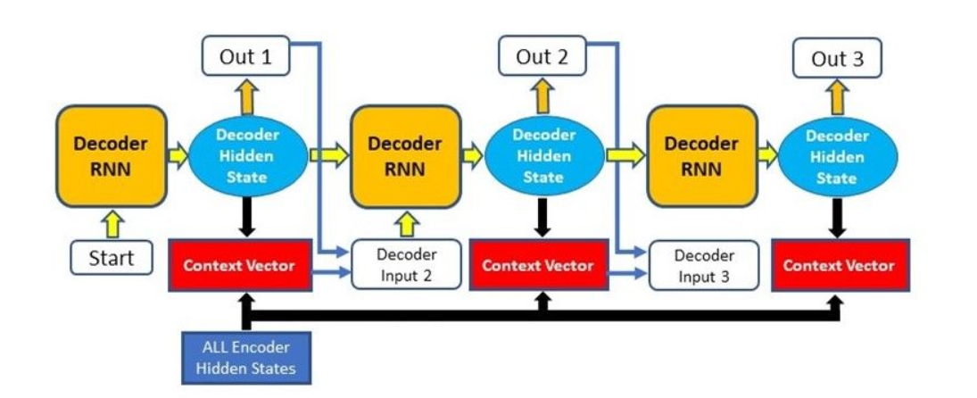

Fig. 6 Attention Mechanism

### 2.2.3 Applications of Seq2Seq Models

Seq2Seq models with attention mechanisms have significantly improved performance in various NLP tasks:

* **Machine Translation**: Seq2Seq models are the backbone of modern machine translation systems, converting text from one language to another while preserving meaning and contexts.
* **Text Summarization**: These models can generate clear summaries of long documents by understanding and condensing the main points.
* **Dialogue Systems**: Seq2Seq models power conversational agents by generating approapriate responses based on the context of the conversation.

Table 1 summarizes the key differences between traditional Seq2Seq models and those enhanced with attention mechanisms.

|  |  |  |
| --- | --- | --- |
| **Feature** | **Traditional Seq2Seq** | **Seq2Seq with Attention** |
| Context Vector | Fixed-size | Dynamic |
| Handling Long Sequences | Poor | Good |
| Computational Complexity | Lower | Higher |
| Performance on Long Texts | Limited | Enhanced |

Table 1. Comparison of Traditional Seq2Seq Models and Seq2Seq Models with Attention Mechanism

In conclusion, Seq2Seq models have been helpful in advancing NLP, particularly with the introduction of the attention mechanism. These models set the stage for even more complexity architectures, such as the Transformer, which leverages self-attention to further enhance performance and scalability.

# 3. The Transformer Model

## 3.1 Architecture Overview

The Transformer model consists of an encoder-decoder architecture, similar to traditional sequence-to-sequence models, but with significant improvements in handling sequential data. The architecture is designed to leverage self-attention mechanisms, which allow the model to weigh the importance of different elements within a sequence. This section provides an overview of the key components and structure of the Transformer model (Figure 4).

### 3.1.1 Encoder

The Transformer model's encoder processes the input sequence and produces a set of hidden representations. It consists of a stack of identical layers, each comprising two main sub-layers: multi-head self-attention and position-wise fully connected feed-forward networks. Each layer is equipped with residual connections around these sub-layers, followed by layer normalization to facilitate training and improve model performance.

**Multi-Head Self-Attention**: This sub-layer allows the encoder to attend to different positions of the input sequence simultaneously, capturing relationships between words regardless of their distance in the sequence. Multi-head attention enhances this capability by running multiple self-attention mechanisms in parallel and concatenating their outputs (Figure 7).

**Feed-Forward Networks**: Following the self-attention sub-layer, the output is passed through a fully connected feed-forward network. This networks include two linear transformations with ReLU activation in the middle, applied independentlly to each position.

Each encoder layer use these sub-layers, enable the model to learn complex representations of the input data.

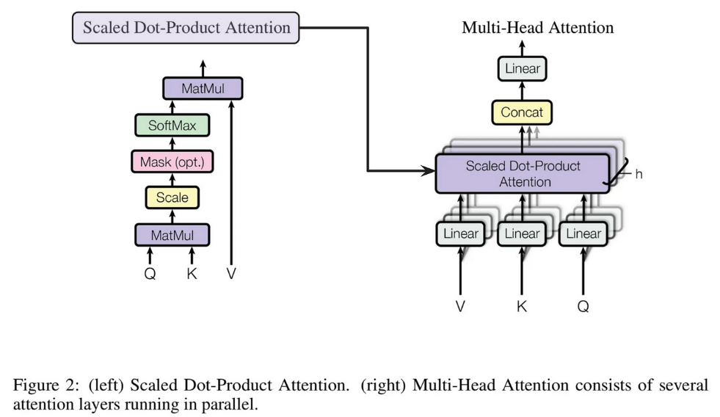

Fig. 7 Multi-Head Self-Attention Mechanism

### 3.1.2 Decoder

The decoder is responsible for generating the output sequence, one element at a time, while attending to the encoder's hidden representations and previously generated elements. As the encoder, the decoder include a stack of same layers, but each layer includes an additional sub-layer for encoder-decoder attention. These attention mechanism enable decoder focusing on relevant parts of input sequence while generating the outputs.

* **Masked Multi-Head Self-Attention**: To prevent the model from attending to future positions in the output sequence, the decoder uses masked multi-head self-attention. This masking ensures that the prediction for a particular position depends only on the known outputs before that position.
* **Encoder-Decoder Attention**: This sub-layer performs attention over the encoder's output representations, allowing the decoder to incorporate information from the entire input sequence. It follows the same multi-head attention mechanism used in the encoder.
* **Feed-Forward Networks**: Similar to the encoder, each decoder layer includes a feed-forward network applied to the output of the attention sub-layers.

Figure 10 illustrates the detailed structure of a Transformer layer, highlighting the connections and operations within the encoder and decoder stacks.

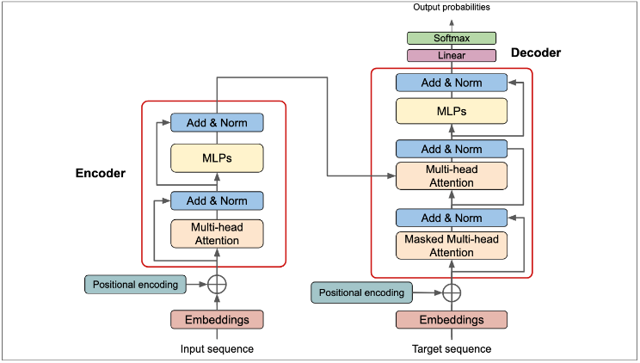

Fig. 8 Detailed Structure of a Transformer Layer

### 3.1.3 Positional Encoding

Since the Transformer does not inherently process sequences in a specific order, positional encoding is used to inject information about the relative or absolute position of tokens in the sequence. These encodes are put into the input embeddings in the bottom of the encoder and decoder stack. The positional encodings use sine and cosine function of different frequencies, allowing the model to learn the order of the sequence (Figure 9).

where is the position and iii is the dimension.

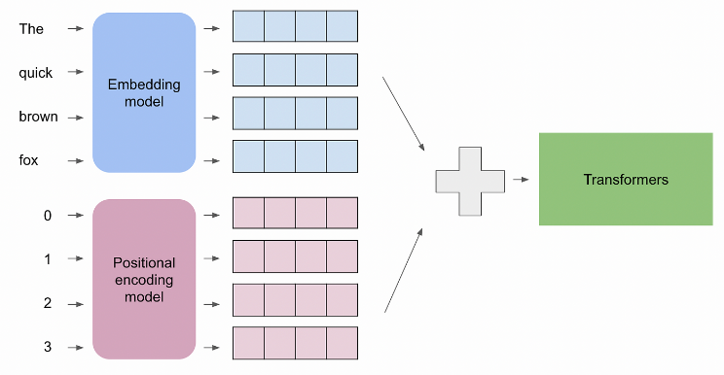

Fig. 9 Positional Encoding

In summary, the Transformer model's architecture, with its encoder-decoder structure, multi-head self-attention mechanisms, and positional encodings, provides a powerful and flexible framework for processing sequential data. This architecture has significantly advanced the state-of-the-art in NLP and other fields, enabling more efficient and effective handling of complex tasks.

## 3.2 Self-Attention Mechanism

The self-attention mechanism is a core component of the Transformer model, enabling it to capture dependencies between different positions in the input sequence more effectively than traditional recurrent neural networks (RNNs). This section delves into the working principles of the self-attention mechanism and its advantages in natural language processing (NLP) tasks.

### 3.2.1 Calculation of Self-Attention

The self-attention mechanism computes a representational of each input tokens by considering the whole sequence. Each token is transformed into three vectors: Query (Q), Key (K), and Value (V). These vectors are derived through learned linear transformations applied to the input embeddings.

1. **Query, Key, and Value Vectors**: For each token in the input sequence, three vectors are generated:

​Where is the input embedding, and ​,, ​are the learned weight matrices for the Query, Key, and Value projections, respectively.

1. **Dot-Product Attention**: The attention scores are calculated by taking the dot product of the Query vector with all Key vectors. This operation measures the similarity between the Query and each Key, resulting in a set of attention scores. Attention

Where is the dimension of the Key vectors. The scores are then scaled by to prevent the dot products from being too big, and a softmax function is used to get the attention weights.

1. **Weighted Sum**: The attention weights are ultilized to compute a weighted sum of the vectors of value, which produce the final outputs for every tokens. This output is a weighted combination of the entire sequence, allowing the model to incorporate contextual information from other tokens.

### 3.2.2 Advantages of Self-Attention

The self-attention mechanism offers several advantages over traditional RNNs and convolutional neural networks (CNNs) in NLP tasks:

* **Parallelization**: Unlike RNNs, which process tokens sequentially, self-attention allows for parallel processing of tokens, significantly speeding up training and inference.
* **Long-Range Dependencies**: Self-attention captures dependencies between distant tokens more effectively than RNNs, which are limited by their sequential nature and vanishing gradient issues.
* **Dynamic Attention**: The attention mechanism dynamically adjusts the focus on different parts of the input sequence for each token, enabling more flexible and context-aware representations.

### 3.2.3 Multi-Head Self-Attention

The Transformer model extends the self-attention mechanism with multi-head attention, which enhances the model's ability to capture diverse features and relationships within the input sequence (Figure 7).

* **Multiple Attention Heads**: Instead of a single attention function, multi-head attention uses multiple attention heads, each with its own set of learned projections for Queries, Keys, and Values. This allows the model to attend to information from different representation subspaces simultaneously.
* **Concatenation and Linear Transformation**: The outputs of the attention heads are concatenated and linearly transformed to produce the final output. This process allows the model to integrate diverse attention patterns and improve its overall representation power.

The multi-head self-attention mechanism can be represented as follows:

where

In summary, the self-attention mechanism, particularly when extended to multi-head attention, forms the backbone of the Transformer model. Its ability to process sequences in parallel, capture long-range dependencies, and dynamically adjust attention weights makes it a powerful tool for a wide range of NLP tasks.

# 4. Applications of Transformers in NLP

## 4.1 Machine Translation

Machine translation is one of the most significant applications of the Transformer model, showcasing its ability to handle complex sequence-to-sequence tasks. Unlike traditional RNN-based models, the Transformer model leverages self-attention mechanisms to process input sequences in parallel, leading to more efficient and accurate translations. This section explores how the Transformer model improves machine translation and its impact on real-world applications.

### 4.1.1 Traditional Approaches

Before the arrival of the Transformer model, machine translation primarily relied on RNNs and LSTMs. These models processed sequences token by token, which often resulted in limitations such as:

* **Sequential Processing**: RNNs process tokens in a sequence, which can be slow and inefficient, especially for long sentences.
* **Vanishing Gradient Problem**: The gradient in RNNs can diminish over long sequences, making it difficult to learn long-range dependencies.
* **Limited Context Understanding**: RNNs may struggle to capture the full context of a sentence, leading to less accurate translations.

### 4.1.2 Transformer Model in Machine Translation

The Transformer model addresses these limitations with its innovative architecture. Key features that enhance its performance in machine translation include:

* **Parallel Processing**: The self-attention mechanism allows the Transformer to process all tokens in a sequence simultaneously, significantly speeding up computation and improving efficiency.
* **Attention Mechanisms**: By applying multi-head self-attention, the Transformer can capture complex dependencies and relationships between words, regardless of their position in the sentence.
* **Positional Encoding**: To retain information about the order of words, the Transformer incorporates positional encodings, which are added to the input embeddings, enabling the model to distinguish between different positions in a sequence.

### 4.1.3 Impact and Advancements

The Transformer model's impact on machine translation has been profound. Some of the notable advancements and applications include:

* **Improved Translation Quality**: The Transformer model has led to significant improvements in translation quality, producing more fluent and accurate translations compared to RNN-based models.
* **Google Translate**: Google has integrated Transformer-based models into its Google Translate service, resulting in more accurate and natural translations across numerous languages (Figure 10).
* **Open Source Models**: Transformer-based models like OpenNMT and MarianMT have been developed and open-sourced, allowing researchers and developers to leverage state-of-the-art machine translation technology in their applications.

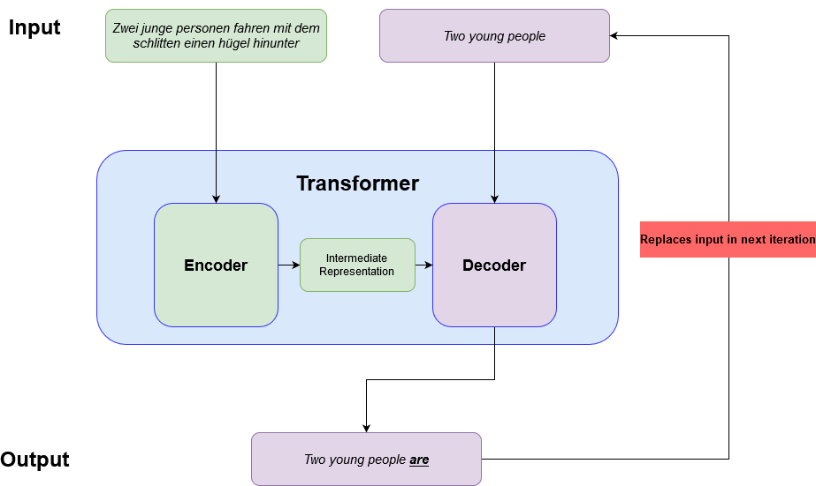

Fig 10. Example of Machine Translation Using Transformer Model

### 4.1.4 Example Translation

To illustrate the effectiveness of the Transformer model in machine translation, consider the following example:

* **Input (English)**: "The Transformer model has revolutionized natural language processing."
* **Output (French)**: "Le modèle Transformer a révolutionné le traitement du langage naturel."

The translated sentence is not only accurate but also fluent, reflecting the model's ability to understand and convey the context and meaning of the original sentence.

### 4.1.5 Challenges and Future Directions

While the Transformer model has significantly advanced machine translation, challenges remain:

* **Resource Intensity**: Training Transformer models requires substantial computational resources and large datasets, which can be a barrier for some organizations.
* **Rare and Low-Resource Languages**: Translating languages with limited training data remains a challenge. Research is keepgoing to develop models that can effectively handle these low-resource languages.

Future directions for research and development in Transformer-based machine translation include:

* **Efficient Model Architectures**: Developing more efficient Transformer variants that require less computational power while maintaining high performance.
* **Multilingual Models**: Creating models that can translate multiple languages within a single framework, improving translation quality and efficiency for low-resource languages.

In conclusion, the Transformer model has transformed machine translation, providing faster, more accurate, and more fluent translations. Its parallel processing capabilities and attention mechanisms have set a new standard in the field, influencing both research and real-world applications.

## 4.2 Text Summarization

Text summarization is another crucial application of the Transformer model, where the goal are to generate concise and coherent summaries from longer documents while retain the key information. The Transformer model's ability to handle long-range dependencies and understands the context makes it particularly effective for this task. This section discusses how the Transformer model enhance text summarization and its impact on practical applications.4.2.1 Traditional Approaches

Traditional methods for text summarization include extractive and abstractive approaches:

* **Extractive Summarization**: This approach involves select and extract key sentences or phrases directly from the original text to create a summary. While it preserve the original wording, it may not always produce a coherent summary.
* **Abstractive Summarization**: This method generate new sentences that capture the essence of the original text. It involves understand the context and meaning, which can be challenging for traditional models like RNNs and LSTMs due to their sequential nature and difficulty in capturing long-term dependencies.

### 4.2.2 Transformer Model in Text Summarization

The Transformer model improves text summarization through its advanced architecture. Key features include:

* **Self-Attention Mechanism**: The ability to focus on different parts of the text simultaneously allow the model to capture important information from various sections of the document.
* **Parallel Processing**: The parallel nature of the Transformer enables it to process long texts efficiently, making it suitable for summarizing lengthy documents.
* **Pre-trained Models**: Models like BERT and GPT, based on the Transformer architecture, has been pre-trained on large corpora and fine-tuned for summarization tasks, leading to state-of-the-art performance.

### 4.2.3 Impact and Advancements

The Transformer model has significantly impacted text summarization, leading to numerous advancements:

* **Improved Summarization Quality**: The summaries generated by Transformer-based models are more coherent and accurate compared to traditional methods, capturing the main ideas effectively.
* **Applications in News and Media**: News agencies and media outlets uses Transformer-based models to automatically generates summaries of articles, providing readers with quick insights into the content.
* **Research and Development**: Transformer models like T5 and BART have been developed and optimized for text summarization, pushing the boundaries of what is possible in this field.

### 4.2.4 Example Summarization

To illustrate the effectiveness of the Transformer model in text summarization, consider the following example:

* **Input (Original Text)**: "The Transformer model have revolutionized natural language processing by introduce a novel self-attention mechanism that allows for parallel processing of input sequences. This have lead to significant advancements in various NLP tasks, include machine translation, text summarization, and question answering."
* **Output (Summary)**: "The Transformer model revolutionized NLP with its self-attention mechanism, enabling parallel processing and advancements in machine translation, text summarization, and question answering."

The summary effectively captures the key points of the original text in a concise manner.

### 4.2.5 Challenges and Future Directions

While the Transformer model has advanced text summarization, challenges remain:

* **Handling Long Documents**: Summarizing very long documents can still be challenging due to memory and computational constraints.
* **Quality of Summaries**: Ensuring the generated summaries are both brief and comprehensive without losing essential information is a continuing challenge.

Future directions for research and development in Transformer-based text summarization include:

* **Efficient Model Architectures**: Developing more efficient Transformer variants to handle longer documents and reduce computational requirements.
* **Domain-Specific Summarization**: Fine-tuning Transformer models for specific domains, such as legal or medical texts, to improve the relevance and accuracy of summaries.

## 4.3 Question Answering

Question answering (QA) is a task in natural language processing (NLP) which involve building systems has ability of automatic answer question posed by human in natural language. The Transformer model have significantly advance QA systems by improve their ability to understand and process complex language queries. This section delve into how the Transformer model enhance question answering and it impact on practical application.

### 4.3.1 Traditional Approaches

Before the advent of the Transformer model, question answering systems typically relied on traditional approaches such as:

* **Rule-Based Systems**: These systems used manual crafted rules to extract answer from structured data sources. While effective in specific domain, they lack flexibility and scalability.
* **Information Retrieval-Based Methods**: These methods involved retrieving relevant documents or passages from a corpus and then extracting answers from the retrieved text. However, they struggled with understanding the context and providing precise answers.
* **RNN and LSTM Models**: These model improve QA by process sequential data, but they face challenge in handle long-range dependencies and understand complex queries.

### 4.3.2 Transformer Model in Question Answering

The Transformer model has revolutionized question answering with its advanced architecture. Key features include:

* **Self-Attention Mechanism**: The self-attention mechanism allow the Transformer to focus on different part of the input text, enable it to understand the context and nuances of the question and the relevant passages.
* **Bidirectional Context Understanding**: Models like BERT (Bidirectional Encoder Representations from Transformers) leverage bidirectional context, understanding both the left and right context simultaneously, lead to more accurate answer.
* **Pre-trained Models**: Pre-trained models such as BERT, RoBERTa, and ALBERT, fine-tuned for QA tasks, have set new benchmarks in QA performance.

### 4.3.3 Impact and Advancements

The Transformer model has had a significant impact on question answering, leading to various advancements:

* **Improved Answer Accuracy**: Transformer-based model provide more accurate and contextually relevant answer compare to traditional method.
* **Applications in Virtual Assistants**: Virtual assistants like Google Assistant, Siri, and Alexa use Transformer-based models to understand and respond to user queries more effectively.
* **Enhanced Search Engines**: Search engines have integrate Transformer-based models to provide direct answer to user queries, improve the overall search experience.

### 4.3.4 Example QA System

To illustrate the effectiveness of the Transformer model in question answering, consider the following example:

* **Input (Question)**: "What is the Transformer model in natural language processing?"
* **Input (Context)**: "The Transformer model has revolutionized natural language processing by introducing a novel self-attention mechanism that allows for parallel processing of input sequences. This has led to significant advancements in various NLP tasks, including machine translation, text summarization, and question answering."
* **Output (Answer)**: "The Transformer model is a novel model in natural language processing that uses a self-attention mechanism for parallel processing of input sequences."

The answer is concise, accurate, and directly relevant to the question.

### 4.3.5 Challenges and Future Directions

While the Transformer model has advanced question answering, challenges remain:

* **Handling Ambiguous Queries**: Understanding and answering ambiguous or poorly phrased questions remains a challenge.
* **Domain-Specific Knowledge**: QA systems need to be fine-tuned with domain-specific knowledge to provide accurate answers in specialized fields such as medicine or law.

Future directions for research and development in Transformer-based question answering include:

* **Few-Shot and Zero-Shot Learning**: Developing model that can answer question with minimal training data or even generalize to new domain without additional training.
* **Multimodal QA Systems**: Integrating text, images, and other data types to build QA systems that can handle multimodal inputs and provide richer, more informative answers.

In conclusion, the Transformer model has significantly improved question answering, providing more accurate and contextually relevant answers. Its advanced architecture and pre-trained models have set a new standard in the field, influencing both research and real-world applications.

## 4.4 Text Generation

Text generation be a crucial application of the Transformer model, involve the create of coherent and contextual relevant text base on a given input. The Transformer model have transform text generation by enhance the ability to produce high-quality text that mimic human writing. This section explore how the Transformer model improve text generation and it impact on practical application.

### 4.4.1 Traditional Approaches

Before the coming of the Transformer model, text generation relied on traditional approaches such as:

* **N-gram Models**: These statistical models predicted the next word in a sequence based on the previous XXX words. While simple, they often produced repetitive and less coherent text.
* **RNN and LSTM Models**: Recurrent neural networks (RNNs) and Long Short-Term Memory (LSTM) networks improve text generation by consider the sequential nature of language. However, they face challenge in capture long-term dependencies and often struggle with maintain coherence over long text.

### 4.4.2 Transformer Model in Text Generation

The Transformer model offers several advantages for text generation:

* **Self-Attention Mechanism**: The self-attention mechanism allows the Transformer to consider all words in the input sequence simultaneously, capturing long-range dependencies and contextual relationships effectively.
* **Parallel Processing**: Unlike RNNs, the Transformer processes all tokens in the input sequence in parallel, making it more efficient and capable of handling longer texts.
* **Pre-trained Models**: Pre-trained model such as GPT (Generative Pre-trained Transformer), GPT-2, and GPT-3 leverage large-scale training on diverse dataset, enable them to generate high-quality and coherent text with minimal fine-tuning.

### 4.4.3 Impact and Advancements

The Transformer model has significantly impacted text generation, leading to numerous advancements:

* **Improved Text Coherence and Relevance**: Transformer-based models produce more coherent and contextually relevant text, closely mimicking human writing.
* **Applications in Creative Writing**: Authors and content creators uses Transformer-based models to assist in write stories, articles, and poetry, enhance creativity and productivity.
* **Chatbots and Virtual Assistants**: Chatbots and virtual assistants uses Transformer-based models to generate natural and engage response, improve user interaction.

### 4.4.4 Example Text Generation

To illustrate the effectiveness of the Transformer model in text generation, consider the following example:

* **Input (Prompt)**: "Once upon a time in a distant land, there was a kingdom where..."
* **Output (Generated Text)**: "...where the sun never set, and the people lived in harmony with nature. The king, wise and benevolent, ruled justly, and the kingdom flourished. However, one day, a mysterious figure appeared at the gates, bringing news that would change the kingdom forever."

The generated text is coherent and continues the narrative in a natural manner.

### 4.4.5 Challenges and Future Directions

While the Transformer model has advanced text generation, challenges remain:

* **Controlling Output**: Ensuring the generated text adheres to specific constraints or guidelines can be challenging, requiring further advancements in model control mechanisms.
* **Ethical Considerations**: Address ethical concern, such as the potential misuse of text generation for create misinformation or harmful content, be crucial.

Future directions for research and development in Transformer-based text generation include:

* **Fine-Tuning for Specific Domains**: Developing model that can generate text tailor to specific domain, such as legal or medical writing, to improve relevance and accuracy.
* **Improving Control and Consistency**: Enhancing mechanism for control the output of text generation model to ensure consistency with user intention and ethical guideline.

# 5. Advantages and Limitations

## 5.1 Advantages

The Transformer model offers several significant advantages over traditional neural network architectures, particularly in the field of Natural Language Processing (NLP).

1. **Parallelization**: Unlike Recurrent Neural Networks (RNNs) and Long Short-Term Memory (LSTM) networks, which process input sequentially, Transformers process the entire input sequence simultaneously. This parallelization significantly speed up training time and allow for more efficient utilize of computational resource.
2. **Long-Range Dependencies**: The self-attention mechanism in Transformers enable the model to capture dependencies between distant elements in the input sequence. This capability be crucial for understand context and relationship in long text, which be a challenge for RNNs and LSTMs.
3. **Scalability**: Transformers can easily scale to larger datasets and more complex tasks. The modular architecture allows for easy adjustments in model size by adding more layers or increasing the size of the hidden states.
4. **Versatility**: The Transformer model have prove effective across a extremely huge range of NLP tasks, include machine translation, text summarization, question answering, and text generation. This versatilty make it a valuable tool in various application.

## 5.2 Limitations

Despite their numerous advantages, Transformers also have some notable limitations.

1. **High Computational Cost**: Transformers require significant computational resources, both in terms of memory and processing power. The self-attention mechanism, while powerful, has a quadratic complexity with respect to the input sequence length, which can make it prohibitively expensive for very long sequences.
2. **Data Hungry**: Transformers typically require large amounts of data to train effectively. This require for large datasets can be a boundary for tasks or domains where labeled data is rare or costly to obtain.
3. **Complexity**: The architecture of Transformers be more complex compare to traditional model. This complexity can lead to longer development time and a steeper learning curve for practitioner new to the model.
4. **Interpretability**: While Transformers excel in performance, understanding and interpreting their internal workings can be challenging. The self-attention mechanism, in particular, creates difficulty in tracing how specific inputs influence outputs, which can be a drawback in applications requiring transparency and explainability.

# 6. Recent Developments and Future Directions

## 6.1 BERT and its Variants

BERT (Bidirectional Encoder Representations from Transformers) represents a significant advancement in the application of Transformer models to NLP tasks. BERT processes text in a bidirectional manner, unlike traditional models that typically process text in either a left-to-right or right-to-left direction. This double directions approach enables BERT to capture more refinement context. This innovation has led to substantial improvements in a variety of tasks, including question answering, sentiment analysis, and named entity recognition.

1. **RoBERTa**: RoBERTa (Robustly Optimized BERT Pretraining Approach) builds on BERT by optimizing the pre-training process. By training on larger datasets and for longer periods, RoBERTa achieves even better performance across many benchmarks.
2. **DistilBERT**: DistilBERT is a smaller, faster, and lighter version of BERT that retains much of its performance. It is designed to reduce the computational load and memory requirements, making it more suitable for deployment in resource-constrained environments.

## 6.2 GPT Series

The Generative Pre-trained Transformer (GPT) series, developed by OpenAI, has set new standards for text generation and language modeling. GPT models are based on the Transformer architecture but are trained to predict the next word in a sentence, making them highly effective for generating coherent and contextually relevant text.

1. **GPT-2**: GPT-2 demonstrated the potential of large-scale pre-training, achieving remarkable results in tasks such as text completion, translation, and summarization. Its release highlighted both the capabilities and ethical considerations of advanced language models.
2. **GPT-3**: GPT-3, with 175 billion parameters, represents a significant leap in scale and capability. It can perform a wide range of tasks with little to no fine-tuning, showcasing impressive versatility and generalization. Applications of GPT-3 include creative writing, programming assistance, and conversational agents.

## 6.3 Future Trends in Transformer Models

The field of NLP is undergoing rapid evolution, with several emerging trends that are poised to enhance the ability and accessibility of Transformer models even further.

1. **Efficient Transformers**: Research is ongoing to develop more efficient Transformer model that can handle longer sequences with reduced computational complexity. Techniques such as sparse attention, linearized self-attention, and memory-efficient architectures aim to make Transformers more scalable and less resource-intensive.
2. **Multimodal Transformers**: Combining text with other data types (e.g., images, audio, and video) is a growing area of interest. Multimodal Transformers aim to understand and generate content that integrates multiple forms of information, leading to more comprehensive AI systems.
3. **Ethical and Explainable AI**: As Transformer models become more powerful and pervasive, there is increasing focus on making them ethical and explainable. Efforts are being made to improve transparency, fairness, and accountability in AI systems to mitigate biases and ensure responsible use.
4. **Continual Learning**: Developing Transformer models capable of continual learning is another key research area. These models can adapt to new information and tasks over time without forgetting previously learned knowledge, enhancing their long-term utility and robustness.

# 7. Conclusion

The Transformer model has revolutionized the field of Natural Language Processing, offering unprecedented improvements in various tasks through its innovative architecture and mechanisms. By leveraging self-attention and positional encoding, Transformers have outperformed traditional models, particularly in handling long-range dependencies and enabling parallel processing.

In this report, we explored the fundamental aspects of the Transformer model, including its architecture, self-attention mechanism, and encoder-decoder structure. We examined its applications in machine translation, text summarization, question answering, and text generation, demonstrating the model's versatility and effectiveness. Additionally, we discussed the advantages of Transformers, such as parallelization and scalability, alongside their limitations, including high computational costs and data requirements.

Recent developments, notably BERT and GPT series, have further showcased the potential of Transformer-based models. BERT's bidirectional processing and GPT's generative capabilities have set new benchmarks in NLP, while ongoing research aims to address existing challenges and expand the models' applicability.

Looking forward, trends such as efficient Transformers, multimodal integration, ethical AI, and continual learning promise to enhance the capabilities and accessibility of these models. As the field evolves, Transformers are poised to play a crucial role in advancing NLP technologies, driving innovation, and enabling more sophisticated and human-like interactions with machines.

In conclusion, the Transformer model's impact on NLP is profound and far-reaching. Its continued development and refinement hold great promise for the future, offering exciting possibilities for research, application, and the broader AI landscape.

# 8. Reference

[1]. Vaswani, A., Shazeer, N., Parmar, N., Uszkoreit, J., Jones, L., Gomez, A. N., ... & Polosukhin, I. (2017). Attention is all you need. *Advances in Neural Information Processing Systems*, 30, 5998-6008.

[2]. Devlin, J., Chang, M. W., Lee, K., & Toutanova, K. (2019). BERT: Pre-training of Deep Bidirectional Transformers for Language Understanding. *arXiv preprint arXiv:1810.04805*.

[3]. Liu, Y., Ott, M., Goyal, N., Du, J., Joshi, M., Chen, D., ... & Stoyanov, V. (2019). RoBERTa: A Robustly Optimized BERT Pretraining Approach. *arXiv preprint arXiv:1907.11692*.

[4]. Sanh, V., Debut, L., Chaumond, J., & Wolf, T. (2019). DistilBERT, a distilled version of BERT: smaller, faster, cheaper and lighter. *arXiv preprint arXiv:1910.01108*.

[5]. Brown, T. B., Mann, B., Ryder, N., Subbiah, M., Kaplan, J. D., Dhariwal, P., ... & Amodei, D. (2020). Language Models are Few-Shot Learners. *arXiv preprint arXiv:2005.14165*.

[6]. Lan, Z., Chen, M., Goodman, S., Gimpel, K., Sharma, P., & Soricut, R. (2020). ALBERT: A Lite BERT for Self-supervised Learning of Language Representations. *arXiv preprint arXiv:1909.11942*.

[7]. Zaheer, M., Guruganesh, G., Dubey, K. A., Ainslie, J., Alberti, C., Ontanon, S., ... & Ahmed, A. (2020). Big Bird: Transformers for Longer Sequences. *arXiv preprint arXiv:2007.14062*.

[8]. Tay, Y., Dehghani, M., Bahri, D., & Metzler, D. (2020). Efficient Transformers: A Survey. *arXiv preprint arXiv:2009.06732*.

[9]. Kalyan, K. S., & Sangeetha, S. (2020). SECNLP: A survey of efficient methods for transforming NLP models. *Journal of Artificial Intelligence Research*, 69, 967-1037.

[10]. Ramesh, A., Pavlov, M., Goh, G., Gray, S., Voss, C., Radford, A., ... & Sutskever, I. (2021). Zero-Shot Text-to-Image Generation. *arXiv preprint arXiv:2102.12092*.

[11]. Radford, A., Kim, J. W., Hallacy, C., Ramesh, A., Goh, G., Agarwal, S., ... & Sutskever, I. (2021). Learning Transferable Visual Models From Natural Language Supervision. *arXiv preprint arXiv:2103.00020*.

[12]. Bommasani, R., Hudson, D. A., Adeli, E., Altman, R., Arora, S., von Arx, S., ... & Liang, P. (2021). On the Opportunities and Risks of Foundation Models. *arXiv preprint arXiv:2108.07258*.

[13]. Thoppilan, R., De Freitas, D., Hall, J., Shazeer, N., Kulshreshtha, A., Cheng, H. T., ... & Le, Q. V. (2022). LaMDA: Language Models for Dialog Applications. *arXiv preprint arXiv:2201.08239*.

[14]. Chowdhery, A., Narang, S., Devlin, J., Bosma, M., Mishra, G., Roberts, A., ... & Dean, J. (2022). PaLM: Scaling Language Modeling with Pathways. *arXiv preprint arXiv:2204.02311*.

[15]. Zeng, A., Kerr, J., Li, Y., Cho, K., Raghunathan, A., Narayanaswamy, S., ... & Sha, F. (2023). GLM: Generalist Language Model. *arXiv preprint arXiv:2305.11171*.

[16]. OpenAI. (2023). GPT-4 Technical Report. *arXiv preprint arXiv:2303.08774*.

#The examples are search from internet.